**SourceTree and Bitbucket Integration**

Version 1.0

Revision History:

|  |  |  |  |  |
| --- | --- | --- | --- | --- |
| Version Number | Date | Created by | Reviewed by | Changes made |
| V1.0 | 12/15/2017 | Gautam.kumar |  |  |

TABLE OF CONTENTS:

1. Purpose 4

2. SourceTree User Guide 4

2.1. Prerequisites 4

2.2. Generating Personal / Private SSH Keys and Public Keys 4

2.3. Cloning Repository 9

2.4 Check Out 15

2.5 Pushing new files or Modified Files to Bitbucket 17

2.6 Pulling changes from Bitbucket Using SourceTree 19

2.7 Resolving Conflicts

# Purpose

The purpose of this document is to act as a reference to the automation team for SourceTree and Bitbucket Integration. This will help the team to integrate SourceTree and Bitbucket. This document guides the user in performing the below activities using SourceTree.

* Clone a repository from Bitbucket
* Push new files/modified files to Bitbucket
* Pull changes from the Bitbucket.
* Resolving conflicts

# SourceTree User Guide

## Prerequisites

This section will describe the tools prerequisites to integrate SourceTree with Bitbucket

* SourceTree Installed on VDAAS machine
* Atlassian account (use this link to create one <https://id.atlassian.com/signup> if required)
* Access to the Bitbucket and Bitbucket project repository

## Generating Personal / Private SSH Keys and Public Keys

After the SourceTree is installed, follow below steps to generate personal and private keys:

1. Launch SourceTree and click on the Tools menu

**Note:** Always launch SourceTree with Privilege Guard as shown in the below screenshot.

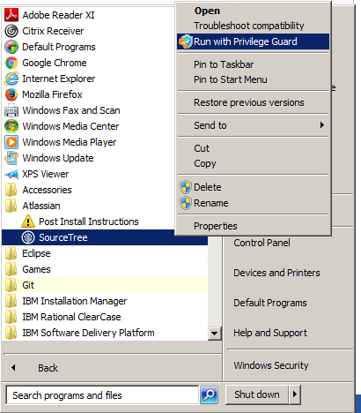

1. Select create or import SSH Keys



1. Click on the “Generate” button in Putty Key Generator Window and hover over your mouse in the highlighted part for random generation of personal key.

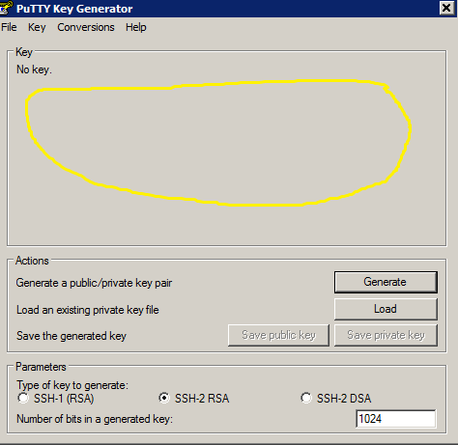

4. After generating the random key, click the “Save Private Key” button and click “Yes” in the dialog.

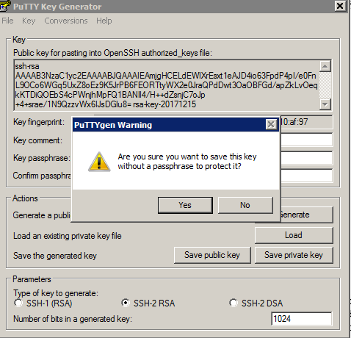

1. Save the Private Key safely because it will be needed further.
2. Save the public key too.
3. Log into Bitbucket using the following link: <https://bitbucket.anthem.com/plugins/servlet/ssh/account/keys> and click on “Add Key”.
4. Copy the public key contents from the PuTTY Key Generator window which is left open from previous steps.

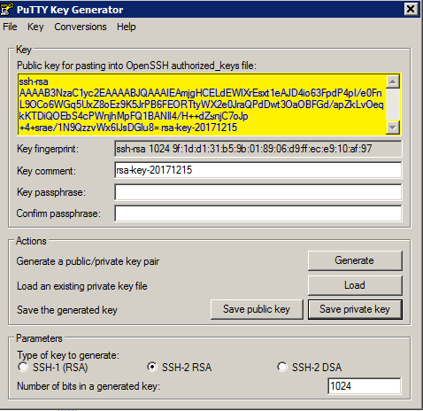

1. Paste the contents into the “Key” area and click the “Add Key” button.

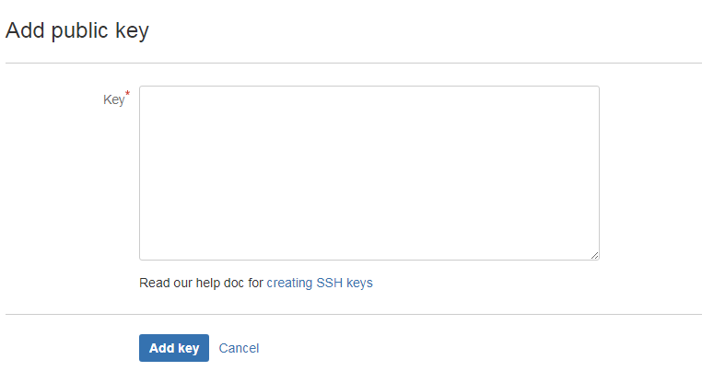

1. And, then verify that key was added.

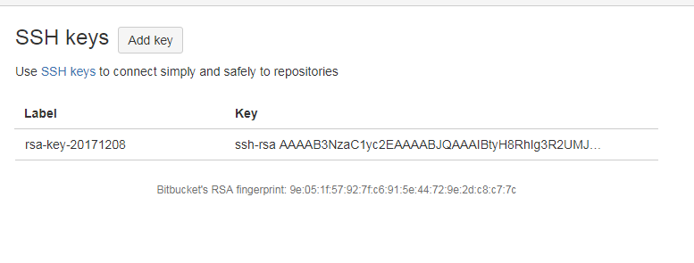

## Cloning Repository

Follow the steps below to clone a personal repo, provided user has “Access” to the corresponding Bitbucket repository.

1. In SourceTree, click on the File🡪 Click on "Clone/New" button.



1. In SourceTree, if a repository is already created then click on “+” icon or if not created click on “Clone” straightaway as shown in above image.

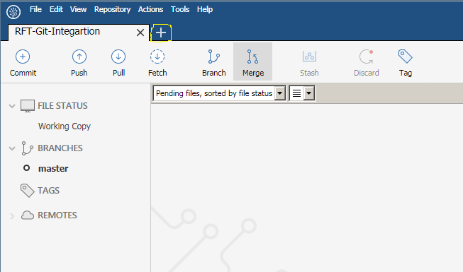

1. Click on “Clone” button

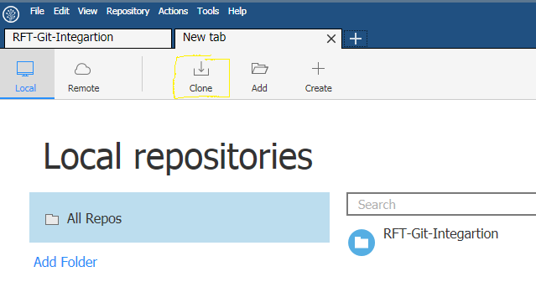

1. After Clicking on “Clone” button below screen pops up:

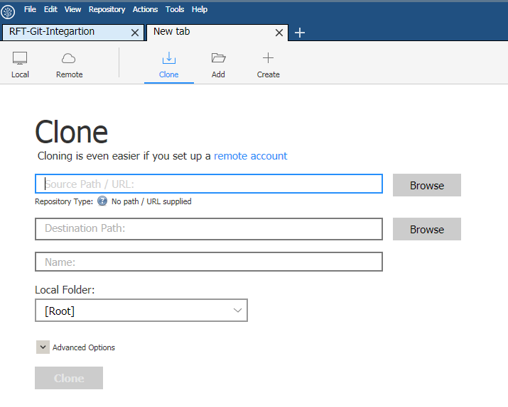

1. Now, in order to fill data in above screen ,go to <https://bitbucket.anthem.com/dashboard>

And then search and click on repository you want to clone (For instance in below screen shot, we clicked on RFT-GIT Integration).

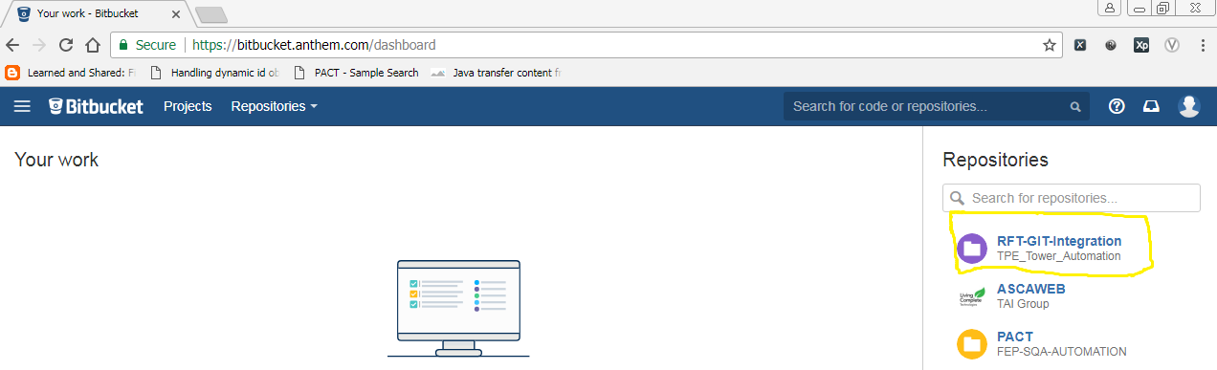

1. Click on “Clone” icon in Bitbucket as shown in below image.

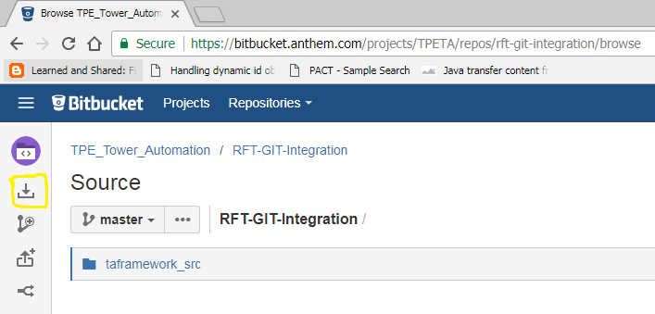

1. Now, Click on “Clone in SourceTree” button as shown in below image. Make Sure SourceTree tool is in open state.

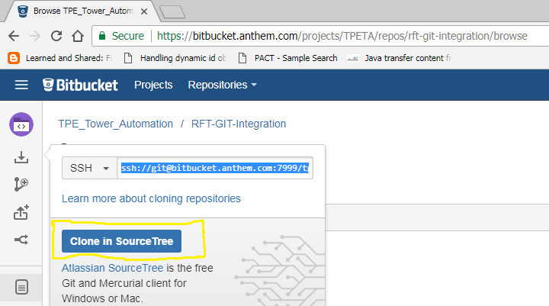

1. The first field in SourceTree gets populated with bit bucket URL as shown below.

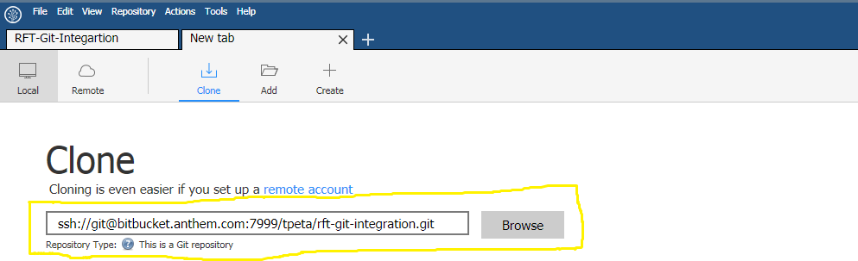

**Note:** After the URL is copied, if you get an error message stating that the provided source is invalid then follow the below steps.

* Click on the Pageant (PuTTY authentication agent) present in the system tray.

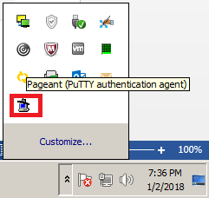

* Pageant Key List window will appear. Click on ‘Add Key’ and then browse to the location where the Private key was saved and add it. (This private key was generated and saved during Step 4)

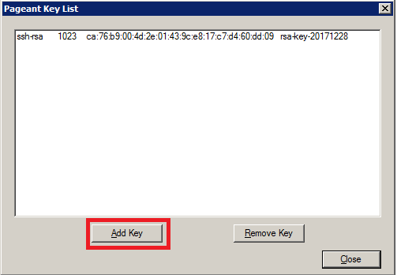

1. The message “Repository Type: This is a GIT repository” should be there as shown in below image in order to make sure that provided source is valid. Now browse the path of the project, preferably in below path “C:\Users\<-Anthem ID->\git\<RepositoryName>” and then click on “Clone” button.

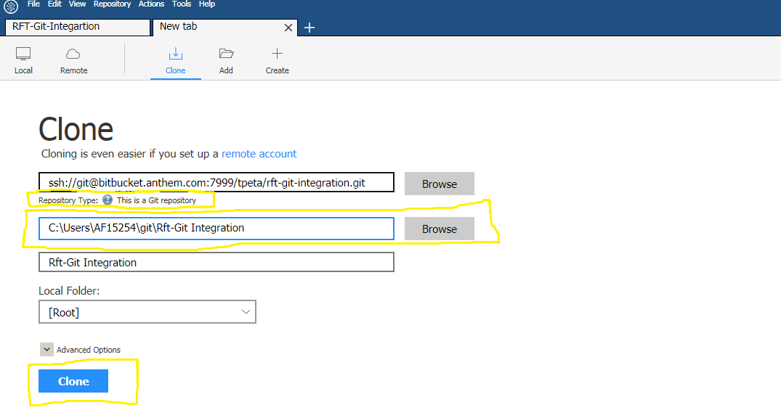

## 2.4 Check Out

1. Once you click on the “Clone”. Next Screen after cloning the SourceTree looks like as shown in below image. Click on “REMOTES” and we can find repo “Origin”.

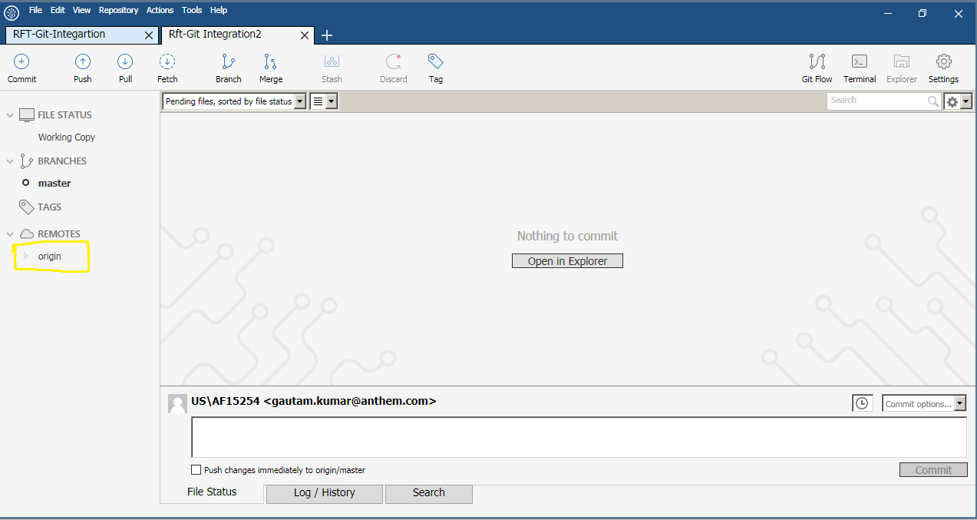

2. Now, click on Origin, and we can witness different branches available and those are:

Development, HEAD and master. Click on “Development” and a user should be able to see the branch (In my case “rft-git-automation”) they are working on.

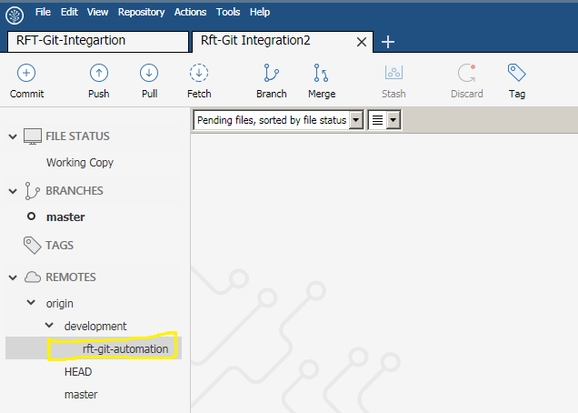

3. Double click on the branch (In my case “rft-git-automation”) to check out and keep a track of the changes that you are working on your machine as shown in above image. In dialog box “checkout” the dropdown “Checkout remote branch:” has default selection of branch you are working on but in case it does not get default populated, a user needs to select the correct branch.

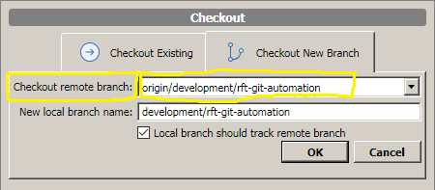

## 2.5 Pushing new files or Modified Files to Bitbucket

Create a new script or Objects file in your local. After creation of new file, we need to push this file using SourceTree to Bitbucket. Follow below steps to push the script using SourceTree:

1. In SourceTree, click on “File Status” tab at bottom. We can find Staged files and Unstaged files sections. If there are no new files created nor any changes made to existing files in your local, then Unstaged files sections will be blank in Source Tree.
2. If there are new files created or existing files modified, then these files will appear under Unstaged files section in Source Tree.

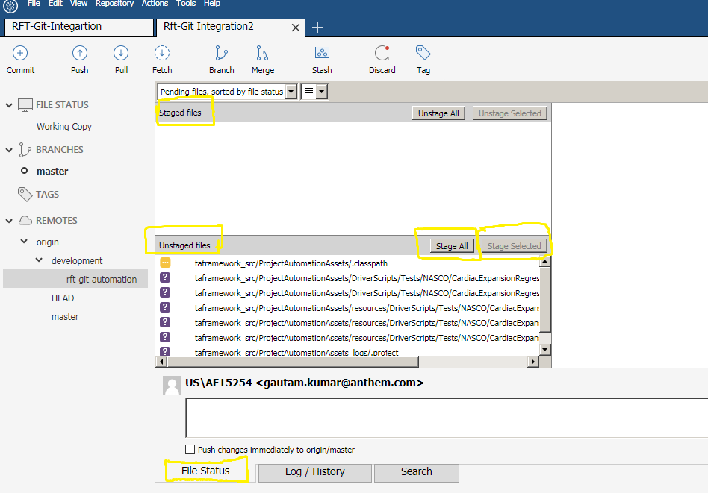

1. Now in order to push a file in SourceTree, either we can select desired files under Unstaged Files section and click on “Stage Selected” button or if user wants all files to be moved to Staged files, then click on “Stage All”. So, after the selection of “Stage Selected” or “Stage All” (As per Use) files will move to Staged Files section and that can be seen in below screenshot.

Now, we need to write a message under “US\AnthemID” to push the file and then click on button “Commit”.

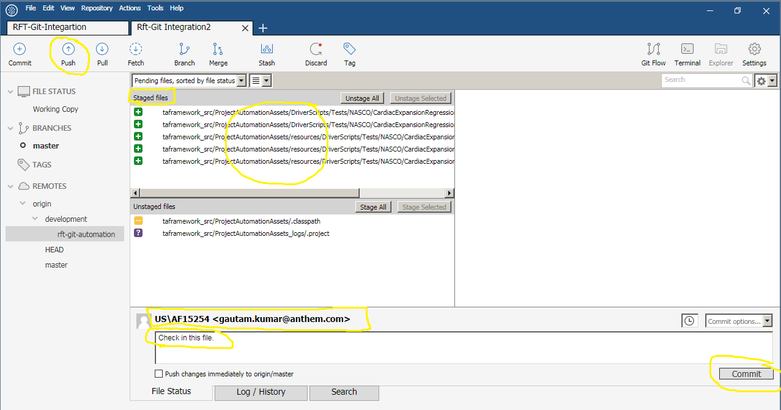

4. Once commit is done, push button will be numbered based on how many commits are pending for “Push”.

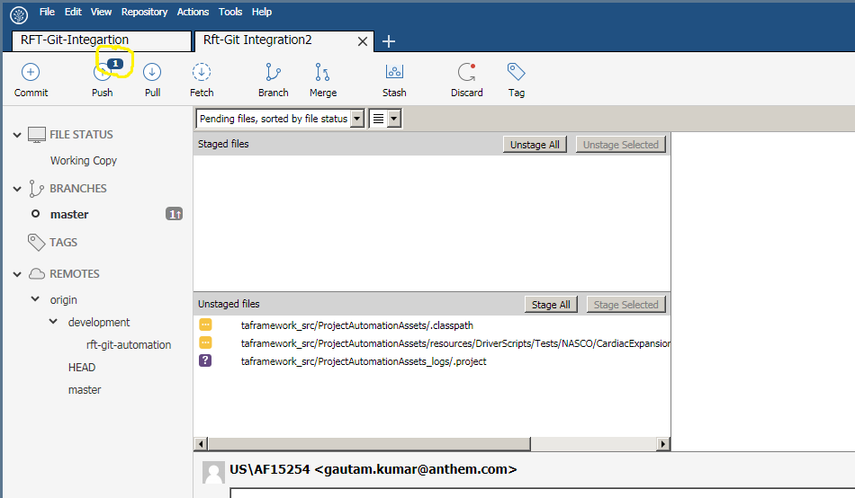

5. Now, click on “Push” button and new pop up window opens. Under the “Local branch” the one branch will be selected by default on which user is working. If user sees not a desired branch checked it shows that they are working on wrong branch. Click on “Push” button and file gets pushed to Bitbucket.

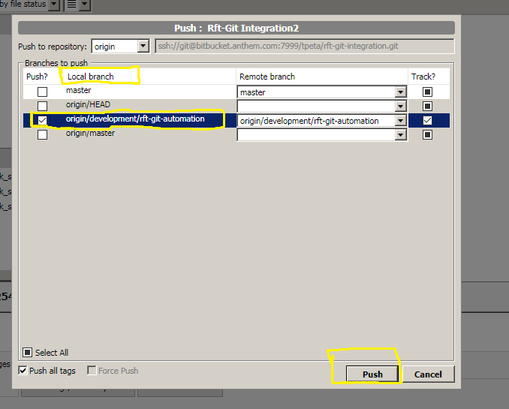

6. Now, go to Bitbucket and look for pushed file in repository created by user in Bit Bucket.

## 2.6 Pulling changes from Bitbucket Using SourceTree

Go to SourceTree, and follow below steps to pull file from Bitbucket using Source Tree.

1. Click on “Pull” and a dialog box opens which has two dropdowns “Pull from remote:” and “Remote branch to pull:” The first dropdown has only one option “origin” and that’s already populated. Second dropdown has also default selection of branch a user is working on or if default selection is not made please select the correct branch from the dropdown. There are four checkboxes in the dialog box and first checkbox is checked by default and rest three check boxes are unchecked and we need to leave them as it is.

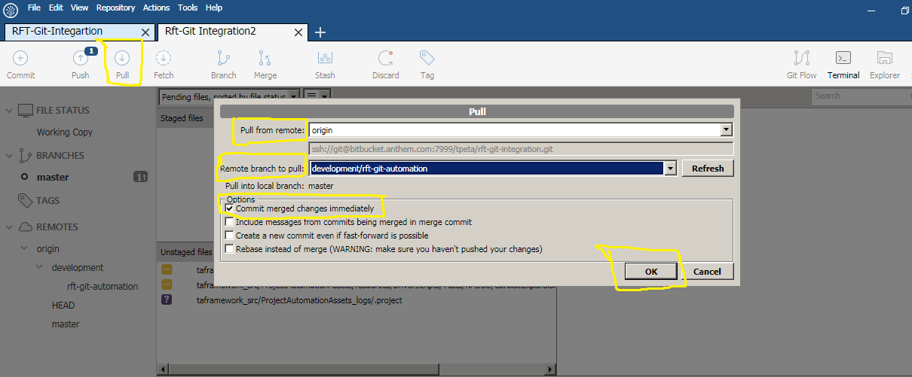

2. Click on button “ok” as shown in above image. Now user gets the changes from Bitbucket repository.